Infosys Springboard Virtual Internship
“Project Name: Automated Python Docstring Generator”
Milestone -2: - Automated Multiple Python Docstring Generator & PEP Violations

1. Introduction
This document describes Milestone 2 of the project
“Automated Python Docstring Generator, Validator & Compliance Analyzer.”
The objective of this milestone is to design and implement a foundational system that:
- Automatically analyzes Python source code
- Extracts structural metadata using Abstract Syntax Tree (AST)
- Generates standardized docstrings
- Evaluates documentation coverage
- Validates compliance with Python documentation standards (PEP 257)
- Reports violations and quality gaps
This milestone focuses on analysis, automation, and reporting, rather than semantic perfection of documentation text.
The generated docstrings act as baseline templates, enabling developers to enhance documentation quality efficiently.

2. Objectives of Milestone 2
The primary objectives of this milestone are:
- Parse Python source code using AST-based static analysis
- Identify:
  - Classes
  - Standalone functions
  - Class methods
- Extract:
  - Function names
  - Parameters (excluding self)
  - Local variables
  - Return statements (basic inference)
  - Existing docstring presence
- Generate automated baseline docstrings
- Support multiple docstring styles
- Produce a docstring coverage report
- Generate PEP 257 compliance and violation reports
- Provide a Streamlit-based interactive UI
- Enable visual inspection of documentation quality

3. Supported Docstring Styles
The system is designed to support multiple documentation standards commonly used in industry.
3.1 Supported Styles
- Google Style
- NumPy Style
- reStructuredText (reST) Style
- PEP 257 Basic Format
Each style follows its official formatting conventions, allowing flexibility across different development teams and organizations.
The user can select the preferred style from the UI before generating docstrings.

4. System Components (Milestone 1 Scope)
4.1 Backend – AST Analyzer & Validator
File: parser.py
Responsibilities:
- Parse Python source code using ast
- Traverse syntax tree
- Extract metadata
- Generate docstring templates
- Compute coverage statistics
- Validate PEP 257 compliance
- Detect documentation violations

4.2 Frontend – Streamlit Interface
File: app.py
Responsibilities:
- Upload Python files
- Select docstring style
- Display generated docstrings
- Visualize coverage metrics
- Display compliance and violation reports
- Present results interactively

5. Backend Architecture Overview
5.1 CodeAnalyzer Class
class CodeAnalyzer(ast.NodeVisitor):
This class extends ast.NodeVisitor and is responsible for traversing the abstract syntax tree.
Stored Attributes
- self.classes
Stores metadata of all detected classes
- self.functions
Stores metadata of standalone functions

5.2 visit_ClassDef()
Triggered whenever a class definition is encountered.
Extracted Information
- Class name
- Class-level variables
- Methods inside the class
- Docstring availability
Sample Metadata Structure
{
"name": "InventoryManager",
"methods": [...],
"class_variables": [...],
"has_docstring": false
}

5.3 visit_FunctionDef()
Triggered for:
- Standalone functions
- Class methods
Delegates detailed extraction to a helper function.

5.4 Function Metadata Extraction
Extracted Fields
- Function name
- Parameters (excluding self)
- Local variables
- Return detection
- Docstring presence
Sample Output
{
"name": "calculate_demand",
"params": ["quantity", "price"],
"returns": "total_cost",
"variables": ["tax", "discount"],
"has_docstring": false
}

6. Automated Docstring Generation
6.1 Baseline Docstring Generator
A dedicated module generates structured docstrings based on extracted metadata.
Features
- Works for:
  - Classes
  - Functions
  - Methods
- Automatically populates:
  - Description placeholder
  - Parameters
  - Return values
  - Variable references
- Supports multiple docstring formats
These docstrings are intended as developer-ready templates, not final documentation.

7. Docstring Coverage Report
The coverage module evaluates how well a codebase is documented.
Metrics Generated
- Total number of classes
- Total number of functions
- Classes with docstrings
- Classes without docstrings
- Functions with docstrings
- Functions without docstrings
- Methods with and without docstrings
Purpose
This helps teams:
- Identify undocumented code
- Measure documentation maturity
- Enforce documentation policies

8. PEP 257 Compliance & Validation
8.1 Why PEP 257?
PEP 257 defines official Python docstring conventions, including:
- One-line docstring format
- Multi-line docstring structure
- Placement rules
- Whitespace conventions
Compliance ensures:
- Readability
- Maintainability
- Industry-standard documentation
- CI/CD readiness

8.2 Validation Using pydocstyle
The project integrates pydocstyle for automated validation.
Validation Workflow
- Python file path is passed to validator
- pydocstyle analyzes documentation
- Violations are collected
- Structured compliance report is generated
Detected Violations Include
- Missing module docstring (D100)
- Missing class docstring (D101)
- Missing function docstring (D103)
- Incorrect formatting
- Improper spacing or summary line issues

8.3 Compliance Report Structure
Each violation includes:
- Rule code (example: D102)
- Description
- Line number
- Affected object
- Severity indicator
This enables precise debugging and correction.

9. UI Integration (Streamlit)
The Streamlit interface provides:
- File upload system
- Docstring style selector
- Generated docstring preview
- Coverage statistics dashboard
- Compliance summary
- Violation listing table

10. Output Screenshots (Placeholders)
10.1 File Upload Interface
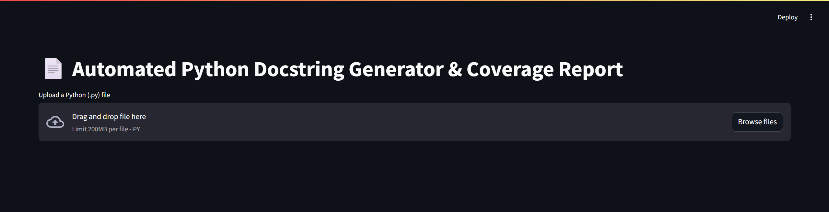
10.2 Docstring Style Selection
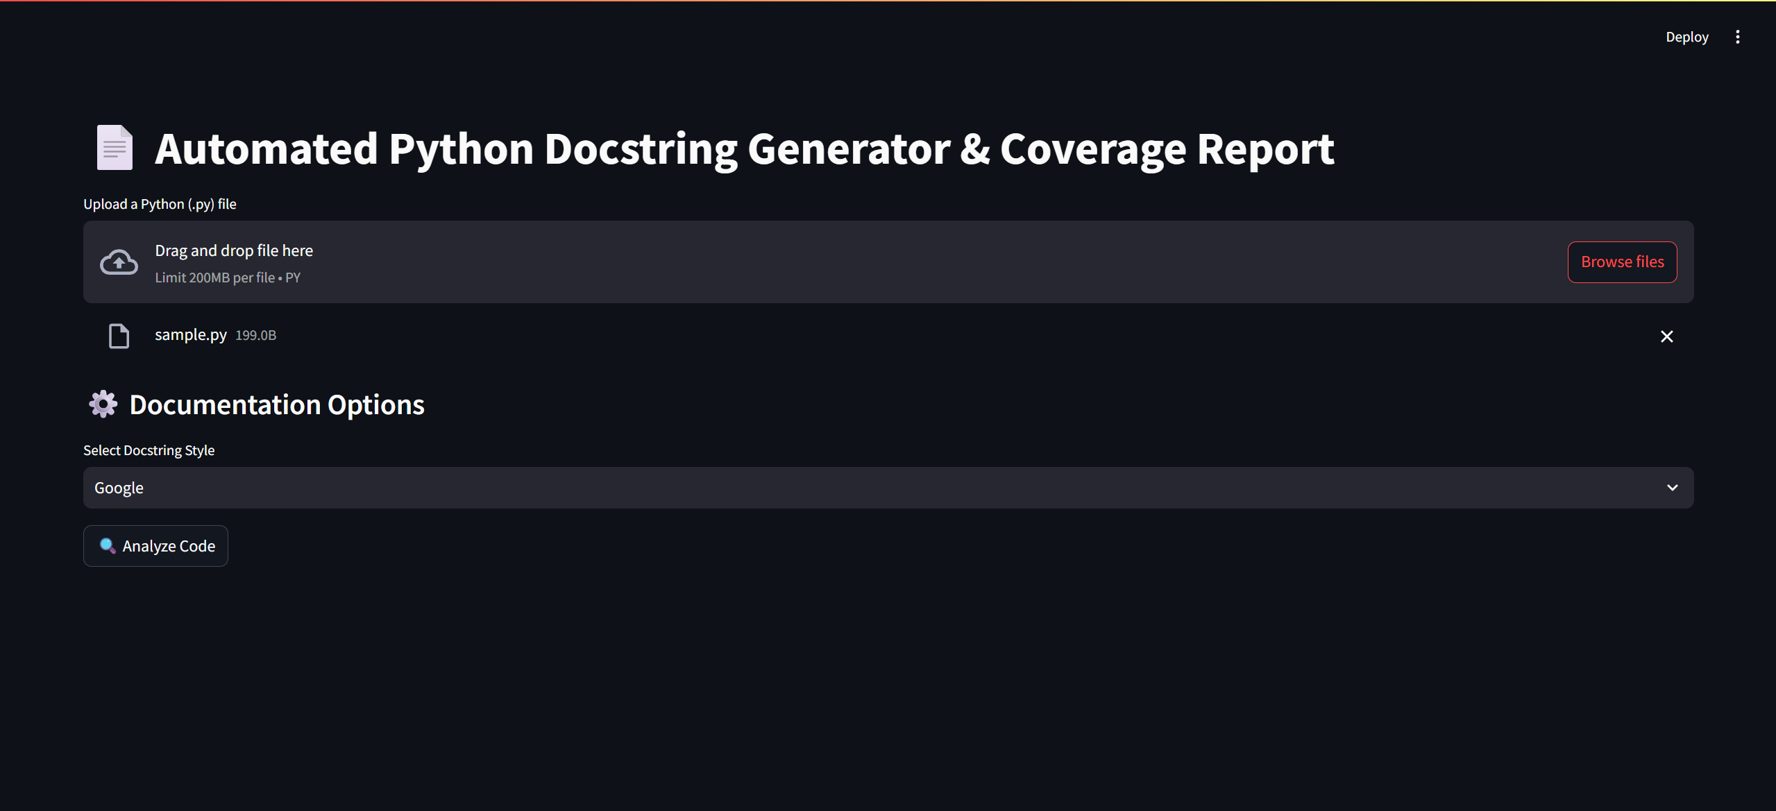

10.3 Generated Docstrings Output
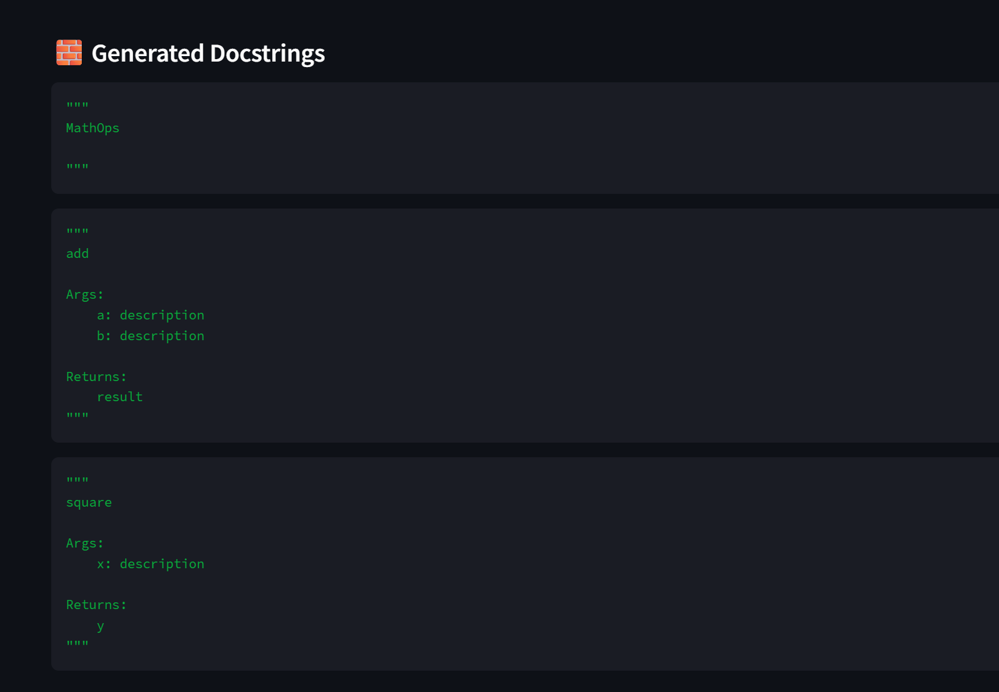
10.4 Coverage Report Dashboard
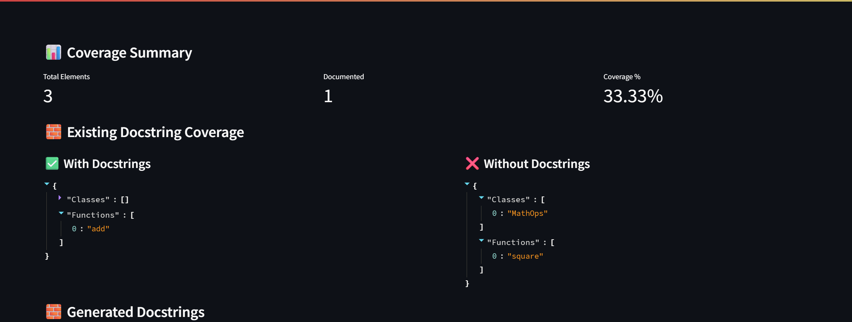
10.5 PEP 257 Compliance & Violations Report
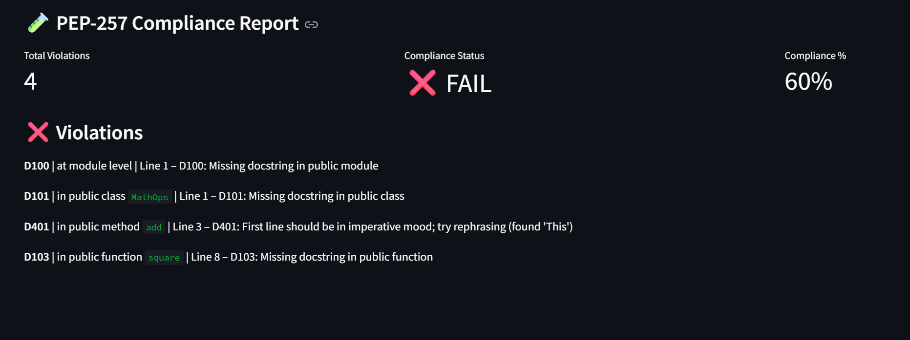
11. Output of Milestone 2
- Successfully parses Python source code using AST
- Identifies structural elements accurately
- Generates automated baseline docstrings
- Supports multiple documentation styles
- Produces documentation coverage report
- Detects PEP 257 violations
- Generates compliance analysis
- Provides interactive visualization via Streamlit

12. Limitations of Milestone 2
- No advanced semantic understanding
- Return type inference is basic
- No automatic natural-language description generation
- No CI/CD pipeline integration
- No enforcement engine (read-only analysis)
These limitations are intentionally addressed in future milestones.

13. Conclusion
Milestone 2 establishes a strong foundation for automated documentation systems by combining:
- Static code analysis
- Standard-compliant validation
- Coverage intelligence
- Developer-friendly visualization

